NHMU-Letterhead-NewsRelease-Paths.eps

|  |  |  |
| --- | --- | --- |
|  | Kristine Chapman  Public Relations Assistant  Natural History Museum of Utah  kchapman@umnh.utah.edu  Office: 801.585.9142  Mobile: 801.971.3936 | Patti Carpenter  Director of Public Relations  Natural History Museum of Utah  pcarpenter@nhmu.utah.edu  Office: 801.585.6369  Mobile: 801.707.6138 |
|  |  |  |

***Re-Bisoning the West: Restoring an American Icon to the Landscape* Lecture and book signing with author Kurt Repanshek on Sunday, September 15 at 1:00pm at NHMU**

Explore the history of the American bison with Kurt Repanshek, award-winning journalist and author of *Re-Bisoning The West, Restoring an American Icon to the Landscape* on Sunday, September 15 at 1 o’clock, at the Natural History Museum of Utah. While at the Museum, take advantage of one last opportunity to view the Museum’s special summer exhibition *Yellowstone: Invisible Boundaries* on its closing day.

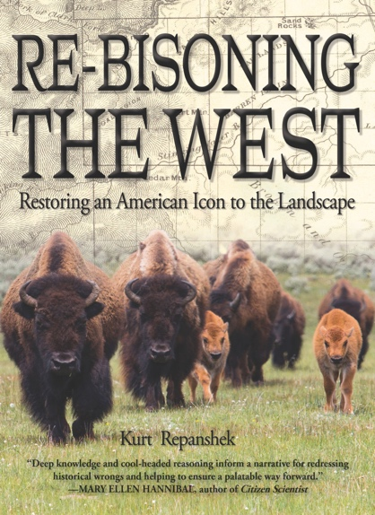

“It has been our pleasure this summer to welcome the public to an amazing exhibition that highlights elk migration and conservation efforts in and around Yellowstone National Park, and we are delighted that Kurt will be presenting exerpts from his new book about the history, repopulation and conservation efforts of the American bison,” says Becky Menlove, the Museum’s interim Executive Director. “Both elk and bison are treasures of the American West and our hope is that through research, cooperation, and increased awareness these majestic creatures will be able to thrive in their natural habitats for generations to come.”

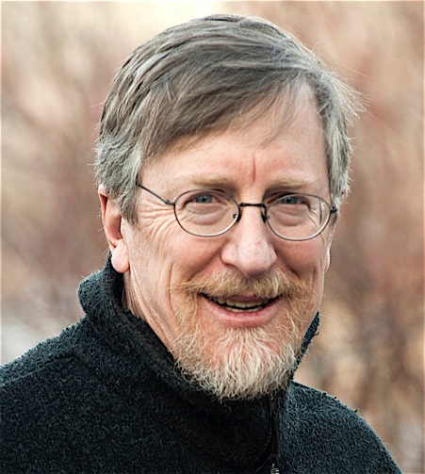As a veteran journalist, advocate and lover of national parks and protected areas, Repanshek’s work has been featured in *Forbes, The New York Times*, *Audubon, National Wildlife*, *Smithsonian* and numerous other publications. He is also founder and editor-in-chief of *National Parks Traveler*, the “World’s #1 Editorially Independent Nonprofit Media Organization dedicated to the coverage of National Parks and Protected Areas.”

Repanshek was inspired to write a book about bison after producing a series of articles about the herds in the National Park System. At first, he began crafting a story focused on bison in Yellowstone National Park, but eventually expanded his vision when he learned about efforts by the U.S. Department of Interior to return bison to some of their native lands.

In May of 2016, the American bison was declared the official National Mammal of the United States. Although bison populations once numbered in the millions across North America, loss of habitat and unregulated hunting dropped the population to just over 1,000 prior to 1900. At present, bison herds are estimated to be around 500,000.

Kurt’s lecture and book signing are included with regular Museum admission and free for Museum Members, University of Utah faculty, staff and students.

For more information, visit <https://nhmu.utah.edu/events/re-bisoning-west-kurt-repanshek>

Be sure to visit [*Yellowstone: Invisible Boundaries*](https://nhmu.utah.edu/yellowstone)before it closes.

Catch the interview with *Yellowstone: Invisible Boundaries* photographer, Joe Riis: <https://www.youtube.com/watch?v=mV3rf1jws_g&feature=youtu.be>