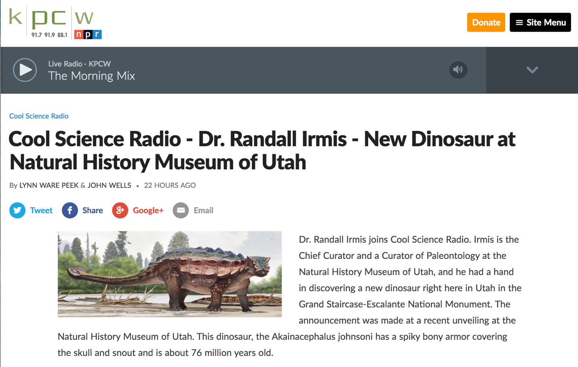

Listen here: <http://www.kpcw.org/post/cool-science-radio-dr-randall-irmis-new-dinosaur-natural-history-museum-utah>