Native Voices Gallery

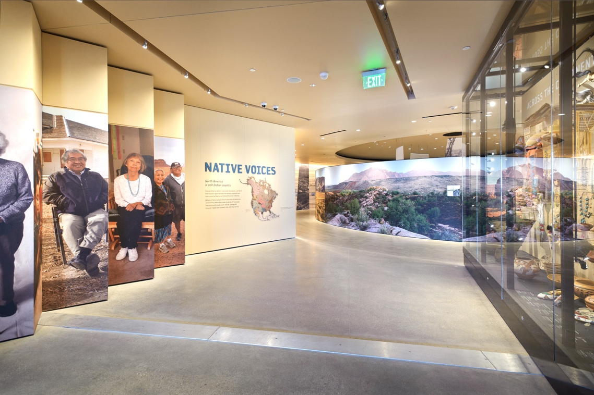
Photo by Stuart Ruckman

The Natural History Museum of Utah’s Native Voices Gallery is a unique exhibit created in collaboration with Utah’s contemporary Indian communities. Laid out in a series of concentric circles, the gallery highlights the unique tribal histories, cultural traditions, stories and works of art from Utah’s 5 Indian Nations; Ute, Paiute, Goshute, Shoshone and Navajo.

The gallery’s circular design and grounded location reflect the important symbolic nature circles play in the lives of Indian culture. Circles embody spiritual energy and a universal understanding of nature, earth, life, seasons and patterns. Visit the gallery to hear first-hand stories and to see beautiful handmade works of art.

First Peoples Gallery

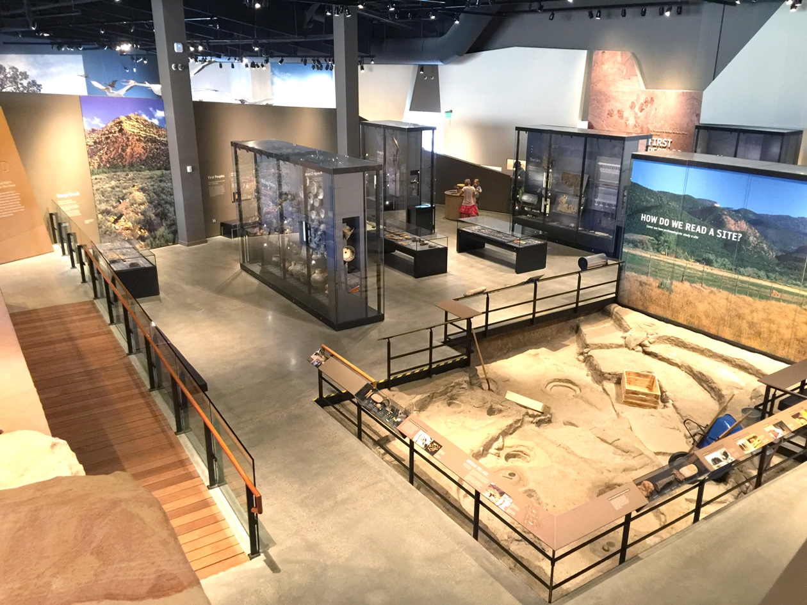

Learn more about some of Utah’s earliest residents at the Museum’s First Peoples Gallery located on Level 3. For more than 11,000 years, ancient people lived in and adapted to the native canyons, deserts, marshes and mountains we now call Utah. They left behind clues and objects that help today’s scientists determine where and how these first people lived. Visit the gallery to learn more about how researchers use the scientific process along with objects and clues to answer questions about the area’s first people.

