NEWS RELEASE
For Immediate Release
Patti Carpenter Rhonda Greenwood
Natural History Museum of Utah -or- Love Communications
pcarpenter@nhmu.utah.edu rgreenwood@lovecomm.net
Cell – 801.707.6138 Cell – 801.706-6202
Office – 801.585.6369

Fourth Annual Indian Art Market slated Oct. 8 - 9 at the
Natural History Museum of Utah
Museum celebrates five years at the Rio Tinto Center with this first of five signature events

SALT LAKE CITY, Sept. 27, 2016 - Enjoy a weekend of Native American art and culture Saturday and Sunday, October 8 - 9, 2016, at the fourth annual Indian Art Market at the Natural History Museum of Utah at the Rio Tinto Center, 301 Wakara Way, Salt Lake City, Utah. The public is invited to the free art show and sale featuring the exquisite handmade work of 23 regional artists from eight tribes spanning seven states. The 2016 Indian Art Market is open from 10 a.m. until 5 p.m. both days.

Indian Art Market visitors will be treated to the vibrant sounds of a native drum circle and hand-carved flute as they browse artist booths featuring jewelry, paintings, pottery, beadwork, fetishes, textiles and photography, set up throughout the Museum’s massive Canyon area.

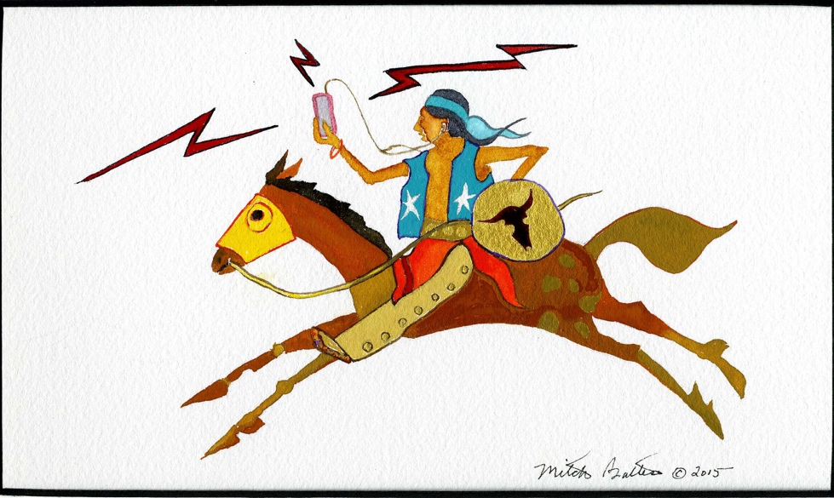
Painting by Mitch Battese

This year, artists will submit one piece to be judged by a group of experts, who will ultimately choose three 2016 winners. Many returning artists and 10 exciting new artists have submitted some of their finest pieces to the 2016 juried show. Special invited guests include 2015 award winners Andy Marion (Best of Show), Norman Lansing (Second Place) and Gilmore Scott (Third Place).

“It’s not an easy task to pick only three winners,” says Museum Store Manager and Event Organizer Suzanne Ruhlman. “There are always so many stunning works entered into our relatively small but exciting show, and this year is no exception. It’s a wonderful opportunity for Utah residents and visitors to support the arts and learn more about native culture here in the state and across the West, and maybe even purchase a unique piece for their own personal collection.”

According to Ruhlman, this is the first year the show and sale will feature photography submissions. The work comes from Los Angeles native Peggy Fontenot who remains devoted to traditional techniques, choosing to process her own prints taken with black and white film. Fontenot—who is Patawomack, Potawatomi and Cherokee—also creates beautiful beadwork.

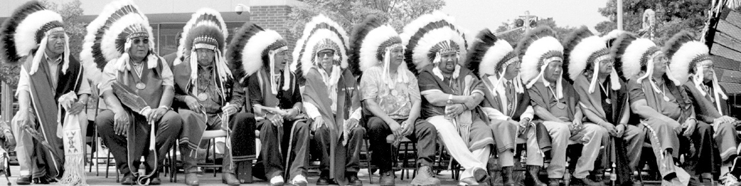
Photo by Peggy Fontenot

Another first to the 2016 market comes from award-winning Navajo quilt maker Susan Hudson. Although quilting is not a traditional Native American art, Hudson’s work highlights how perfectly quilting showcases native patterns, symbols and tribal stories.

Guests interested in viewing other works of historic Indian art may choose to visit the Museum’s Native Voices Gallery, located on the fifth floor, or stop by the First Peoples’ Gallery (level three), where they can see important artifacts from some of Utah’s earliest residents. Regular entrance fees for admission will be charged in order to visit the Museum galleries. For more information about upcoming five-year anniversary events, visit https://nhmu.utah.edu/five.

# # #

About the Natural History Museum of Utah
The Natural History Museum of Utah is one of the leading scientific research and cultural institutions in the country. Established in 1963, the Museum’s collections contain over 1.2 million objects and offer innovative exhibitions and educational programs to thousands of residents and visitors each year, including traveling and permanent exhibits, special events and other programs. With an expected attendance of 180,000 visitors a year, the Museum also offers a variety of outreach programs to communities and schools throughout Utah, reaching every school district in the state annually. The Museum has an active science program with more than 30 scientists and 10 field exhibitions each year.

