NHMU-Letterhead-NewsRelease-Paths.eps

|  |  |  |
| --- | --- | --- |
|  | Kristine Chapman  Public Relations Assistant  Natural History Museum of Utah  kchapman@umnh.utah.edu  Office: 801.585.9142  Mobile: 801.971.3936 | Patti Carpenter  Director of Public Relations  Natural History Museum of Utah  pcarpenter@nhmu.utah.edu  Office: 801.585.6369  Mobile: 801.707.6138 |
|  |  |  |

**The Natural History Museum of Utah Shares Groundbreaking Research on Animal Migration with Special Exhibit, *YELLOWSTONE: INVISIBLE BOUNDARIES,* Opening June 29**

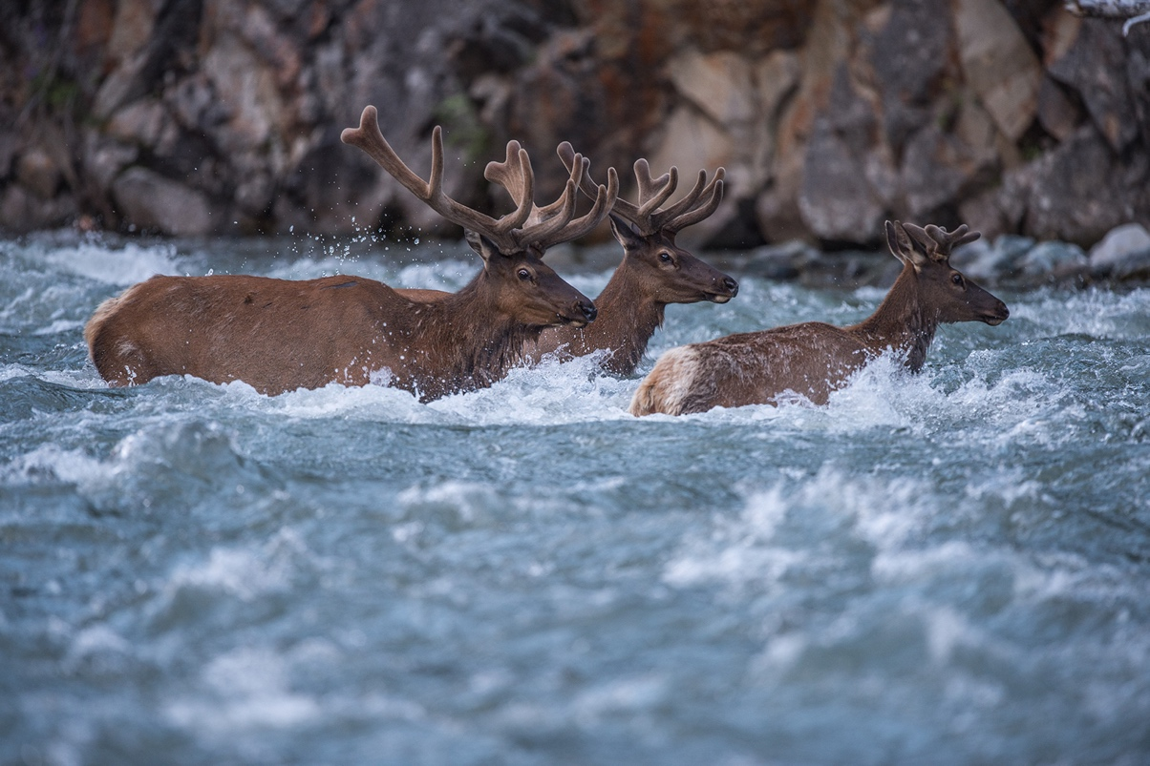

Bull elk forging the Shoshone River during their migration towards Yellowstone National Park.

©Joe Riis/www.joeriis.com

Explore the incredible challenges migratory elk and other dynamic wildlife face as they trek from the protected landscapes of the Greater Yellowstone Ecosystem to the surrounding private and government-owned lands in search of vital winter resources.

*Yellowstone: Invisible Boundaries*, a visually stunning special exhibition, opens to the public on June 29 and runs through September 15, 2019, at the Natural History Museum of Utah at the Rio Tinto Center, University of Utah. In the perfect fusion of science and art, the exhibition features large-scale photographs, cultural objects, original works of art, compelling film, and an interactive 3-D migration map of the Greater Yellowstone Ecosystem.

Members of the press are invited to get a sneak peek of the exhibition on Friday, June 28, 2019 from 10am to 1pm and tour the exhibition with wildlife photojournalist, National Geographic fellow (2017) and 2016 National Geographic Adventurer of the year, Joe Riis. Riis will give a public lecture on Saturday, June 29th where he will sign copies of his book, *Yellowstone Migrations* (available for sale at the event).

Wildlife ecologist Arthur Middleton, and curator of the Yellowstone exhibition, is also available for interviews via skype or phone.

“We’re delighted to showcase the collaborative power of science and art through the works of wildlife ecologist Arthur Middleton, wildlife photojournalist Joe Riis, artist James Prosek and filmmaker Jenny Nichols,” exclaims Becky Menlove, the Museum’s associate director for visitor experience. “This multi-disciplinary exhibit highlights the reality that the needs of wildlife are not constrained by human-imposed boundaries and invites audiences to explore the complex relationships between land conservation and migratory herds.”

The idea of proposing an unconventional project to document and map elk migrations in and around Greater Yellowstone began incubating when Middleton and Riis first met at the University of Wyoming in 2010. A few years later, the proposed project and the duo became winners of the prestigious 2013 Camp Monaco Prize, awarded by Prince Albert II of Monaco. The $100,000 cash prize is presented to applicants whose scientific study and public education efforts promote understanding and improve conservation initiatives for native biodiversity of the Greater Yellowstone Ecosystem.

Several years into the project, in an attempt to fill a hole in one area of data, Middleton and Riis spent two wild summers following and documenting the harrowing journey of one particular elk herd. The footage eventually became an extraordinary National Geographic documentary, [*Take an Epic Journey with the Elk of Yellowstone*.](https://youtu.be/rS3P9gI7CUU) Videographer Jenny Nichols captures the experiences of Middleton and Riis as they trek over snow-capped peaks, navigate treacherous canyons, set and reset motion-activated camera traps, place and monitor GPS collars and endure more than 1,500 miles on horseback. Middleton and Riis were honored yet again in 2016 for their groundbreaking research, when National Geographic named them Adventurers of the year.

*Yellowstone: Invisible Boundaries* was organized by the Buffalo Bill Center of the West, Cody Wyoming. To download a copy of this press release or the accompanying images available for media use, visit: <https://nhmu.utah.edu/newsdesk>.

For additional information about the exhibit and its summer stop in Utah, visit the Museum’s main site at: <https://nhmu.utah.edu/yellowstone>.

# # #

**About the Natural History Museum of Utah**

The Natural History Museum of Utah is one of the leading scientific research and cultural institutions in the country. Established in 1963, the Museum’s collections contain over 1.6 million objects and offers innovative exhibitions and educational programs to thousands of residents and visitors each year, including traveling and permanent exhibits, special events and other programs. With an expected attendance of 300,000 visitors a year, the Museum also offers a variety of outreach programs to communities and schools throughout Utah, reaching every school district in the state annually. The Museum has an active science program with more than 30 scientists and 10 field exhibitions each year.